Project Development
Phase-I
Code and Outputs

Date | 14 February 2026
Team ID | LTVIP2026TMIDS43288
Project Name | Project – Online Payments Fraud Detection Using Machine Learning
Maximum Marks | 4 Marks

Online Payments Frauds Detection:
In response to the surge in online credit/debit card transactions, our project, "Online Payments Fraud Detection Using Machine Learning," pioneers a cutting-edge solution.
Leveraging classification algorithms like Decision Trees, Random Forest, SVM, Extra Tree, and XGBoost, we aim to detect and prevent fraud effectively.
The system ensures real-time monitoring, issues alerts for potential fraud, and features continuous learning for adaptation. With a user-friendly interface, administrators can efficiently review flagged transactions.
This initiative contributes to a secure online payment ecosystem through an adaptive, accurate, and efficient fraud detection system. Integration involves flask and IBM deployment.

Technical Architecture:
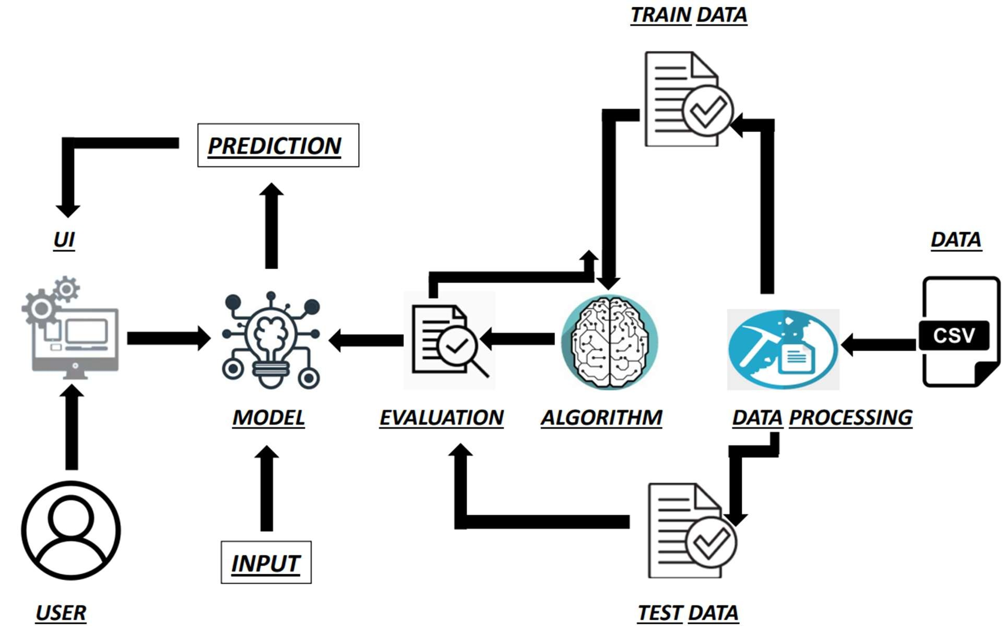

fraud-detection

1 Data Collection
We are using a dataset from kaggle for this project
https://www.kaggle.com/datasets/rupakroy/online-payments-fraud-detection-dataset

2 Visualising and analysing data

2.0.1 Importing libaries
[1]:
import
numpy
as
np
import
pandas
as
pd
import
matplotlib
.
pyplot
as
plt
import
seaborn
as
sns
from
scipy
import
stats
from
sklearn
.
preprocessing
import
LabelEncoder
from
sklearn
.
model_selection
import
train_test_split
from
sklearn
.
ensemble
import
RandomForestClassifier
from
sklearn
.
metrics
import
accuracy_score
from
sklearn
.
tree
import
DecisionTreeClassifier
from
sklearn
.
ensemble
import
ExtraTreesClassifier
from
sklearn
.
svm
import
SVC
import
xgboost
as
xgb
from
sklearn
.
metrics
import
f1_score
from
sklearn
.
metrics
import
classification_report, confusion_matrix
import
warnings
import
pickle

2.0.2 Read dataset
[3]: df
[2]:
df
=
pd
.
read_csv(
"
fraud detection dataset.csv
"
)
[3]: | step type | amount nameOrig oldbalanceOrg \
0 | 1 PAYMENT | 9839.64 C1231006815 170136.00
1 | 1 PAYMENT | 1864.28 C1666544295 21249.00
2 | 1 TRANSFER | 181.00 C1305486145 181.00
3 1 CASH_OUT 181.00 C840083671 181.00 4 1 PAYMENT 11668.14 C2048537720 41554.00
… … … … … …
- 743 CASH_OUT 339682.13 C786484425 339682.13
- 743 TRANSFER 6311409.28 C1529008245 6311409.28
- 743 CASH_OUT 6311409.28 C1162922333 6311409.28 6362618 743 TRANSFER 850002.52 C1685995037 850002.52
6362619 743 CASH_OUT 850002.52 C1280323807 850002.52
newbalanceOrig nameDest oldbalanceDest newbalanceDest isFraud \
- 160296.36 M1979787155 0.00 0.00 0
- 19384.72 M2044282225 0.00 0.00 0
- 0.00 C553264065 0.00 0.00 1
- 0.00 C38997010 21182.00 0.00 1
- 29885.86 M1230701703 0.00 0.00 0
… … … … … …
- 0.00 C776919290 0.00 339682.13 1
- 0.00 C1881841831 0.00 0.00 1
- 0.00 C1365125890 68488.84 6379898.11 1
- 0.00 C2080388513 0.00 0.00 1
- 0.00 C873221189 6510099.11 7360101.63 1
isFlaggedFraud
- 0
- 0
- 0
- 0
- 0
… …
- 0
- 0
- 0
- 0
- 0
[6362620 rows x 11 columns]
[4]: df.drop(["isFlaggedFraud"], axis=1, inplace=True)
Here the “isFlagged” is removed as it has only 1 value i.e, 0 and is unecessary
[5]:
df
.
head()
[5]: step type amount nameOrig oldbalanceOrg newbalanceOrig \
- 1 PAYMENT 9839.64 C1231006815 170136.0 160296.36
- 1 PAYMENT 1864.28 C1666544295 21249.0 19384.72
- 1 TRANSFER 181.00 C1305486145 181.0 0.00
- 1 CASH_OUT 181.00 C840083671 181.0 0.00
- 1 PAYMENT 11668.14 C2048537720 41554.0 29885.86
nameDest oldbalanceDest newbalanceDest isFraud
- M1979787155 0.0 0.0 0
- M2044282225 0.0 0.0 0
- C553264065 0.0 0.0 1
- C38997010 21182.0 0.0 1
- M1230701703 0.0 0.0 0
[6]:
df
.
tail()
[6]: step type amount nameOrig oldbalanceOrg \
- 743 CASH_OUT 339682.13 C786484425 339682.13
- 743 TRANSFER 6311409.28 C1529008245 6311409.28
- 743 CASH_OUT 6311409.28 C1162922333 6311409.28 6362618 743 TRANSFER 850002.52 C1685995037 850002.52
6362619 743 CASH_OUT 850002.52 C1280323807 850002.52
newbalanceOrig nameDest oldbalanceDest newbalanceDest isFraud
- 0.0 C776919290 0.00 339682.13 1
- 0.0 C1881841831 0.00 0.00 1
- 0.0 C1365125890 68488.84 6379898.11 1
- 0.0 C2080388513 0.00 0.00 1
- 0.0 C873221189 6510099.11 7360101.63 1
[7]:
df
.
columns
[7]: Index(['step', 'type', 'amount', 'nameOrig', 'oldbalanceOrg', 'newbalanceOrig',
'nameDest', 'oldbalanceDest', 'newbalanceDest', 'isFraud'], dtype='object')
We will modify the “matplotlib” plots to “ggplot” style as used in R programming. Additionally, we will also suppress any warning messages generated by matplotlib or any other libraries.
[8]:
plt
.
style
.
use(
"
ggplot
"
)
warnings
.
filterwarnings(
"
ignore
"
)
[9]:
df[
"
isFraud
"
]
.
value_counts()
[9]:
isFraud
- 6354407
- 8213
Name: count, dtype: int64
0 means legal transaction and 1 means fraudulent transaction
It is clearly seen that the number of legal transactions is way more than the number of fraudulent transactions which makes it an imbalanced dataset
Hence we need to balance it
[10]:
legit
=
df[df[
"
isFraud
"
]
==
0
]
[11]:
fraud
=
df[df[
"
isFraud
"
]
==
1
]
We shall make the number of legal transactions equal to the number of fraudulent transactions to make it even
[12]:
legit
=
legit
.
sample(n
=
8213
)
[13]:
legit
.
shape, fraud
.
shape
[13]: ((8213, 10), (8213, 10))
Now they are equal
[14]:
new_df
=
pd
.
concat([legit, fraud], axis
=
0
)
[15]:
new_df
.
head()
[15]: step type amount nameOrig oldbalanceOrg \ 2472014 204 PAYMENT 2711.51 C1894501645 155609.95 1329496 137 PAYMENT 50062.45 C1730518885 0.00
3569677 260 TRANSFER 142407.65 C2110794520 0.00 1698217 159 PAYMENT 11379.43 C195346257 25424.00
5190368 369 CASH_IN 220293.91 C481241988 293672.58
newbalanceOrig nameDest oldbalanceDest newbalanceDest isFraud
2472014 152898.44 M1335909317 0.00 0.00 0 1329496 0.00 M341053193 0.00 0.00 0
3569677 0.00 C2102807958 830469.20 1181738.48 0
1698217 14044.57 M371911161 0.00 0.00 0
5190368 513966.49 C1138529772 3017311.84 2797017.93 0
[16]:
new_df
.
tail()
[16]: step type amount nameOrig oldbalanceOrg \
- 743 CASH_OUT 339682.13 C786484425 339682.13
- 743 TRANSFER 6311409.28 C1529008245 6311409.28
- 743 CASH_OUT 6311409.28 C1162922333 6311409.28 6362618 743 TRANSFER 850002.52 C1685995037 850002.52
6362619 743 CASH_OUT 850002.52 C1280323807 850002.52
newbalanceOrig nameDest oldbalanceDest newbalanceDest isFraud
- 0.0 C776919290 0.00 339682.13 1
- 0.0 C1881841831 0.00 0.00 1
- 0.0 C1365125890 68488.84 6379898.11 1
- 0.0 C2080388513 0.00 0.00 1
- 0.0 C873221189 6510099.11 7360101.63 1
[17]:
new_df[
"
isFraud
"
]
.
value_counts()
[17]: isFraud
- 8213
- 8213
Name: count, dtype: int64
[18]:
new_df
.
to_csv(
'
balanced_dataset.csv
'
, index
=
False
, encoding
=
'
utf-8
'
)
[19]:
corr
=
df
.
corr(numeric_only
=
True
)
[20]:
corr
[20]:
step
amount oldbalanceOrg newbalanceOrig \
step 1.000000 0.022373 -0.010058 -0.010299
amount 0.022373 1.000000 -0.002762 -0.007861
oldbalanceOrg -0.010058 -0.002762 1.000000 0.998803
newbalanceOrig -0.010299 -0.007861 0.998803 1.000000
oldbalanceDest 0.027665 0.294137 0.066243 0.067812
newbalanceDest 0.025888 0.459304 0.042029 0.041837
isFraud 0.031578 0.076688 0.010154 -0.008148
oldbalanceDest newbalanceDest isFraud
step | 0.027665 | 0.025888 0.031578
amount | 0.294137 | 0.459304 0.076688
oldbalanceOrg | 0.066243 | 0.042029 0.010154
newbalanceOrig | 0.067812 | 0.041837 -0.008148
oldbalanceDest | 1.000000 | 0.976569 -0.005885
newbalanceDest | 0.976569 | 1.000000 0.000535
isFraud | -0.005885 | 0.000535 1.000000
[21]:
sns
.
heatmap(corr, annot
=
True
)
[21]: <Axes: >
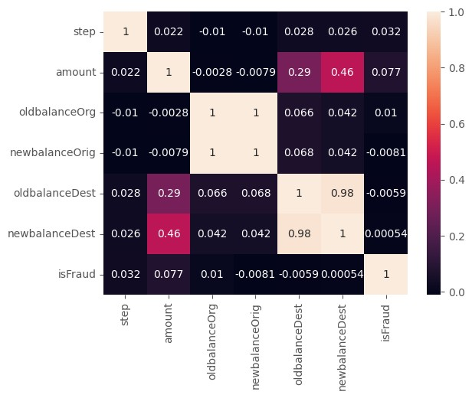

2.0.3 Univariate analysis
The process of understanding data with a single feature is called univariate analysis
[22]:
sns
.
histplot(data
=
new_df, x
=
"
step
"
)
[22]: <Axes: xlabel='step', ylabel='Count'>
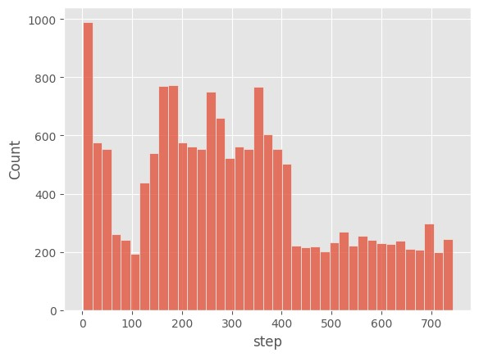
[23]:
sns
.
boxplot(data
=
new_df, x
=
"
step
"
)
[23]: <Axes: xlabel='step'>
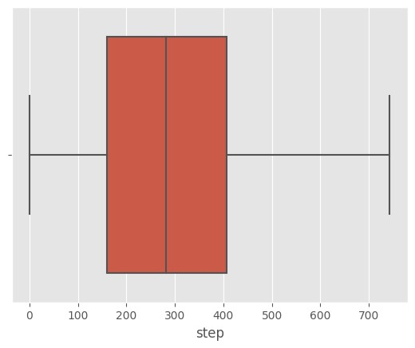
[24]:
sns
.
countplot(data
=
new_df, x
=
"
type
"
)
[24]: <Axes: xlabel='type', ylabel='count'>
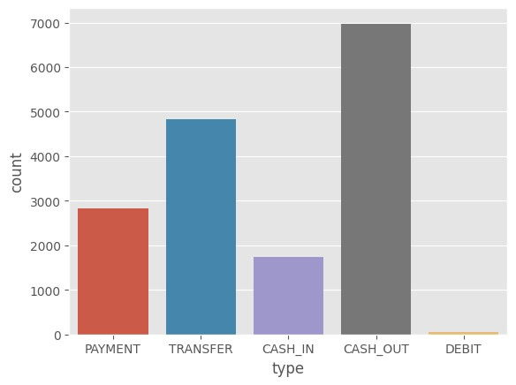
[25]:
sns
.
histplot(data
=
new_df, x
=
"
amount
"
)
[25]: <Axes: xlabel='amount', ylabel='Count'>
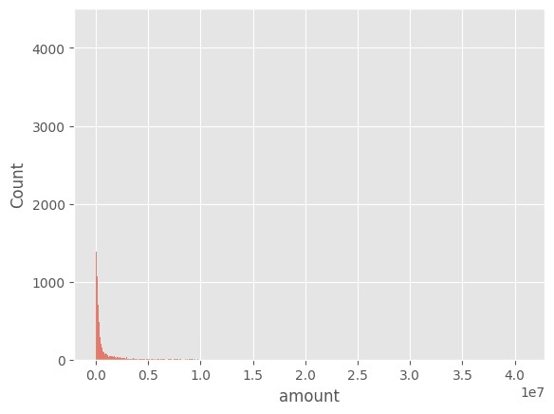
[26]:
sns
.
boxplot(data
=
new_df, x
=
"
amount
"
)
[26]: <Axes: xlabel='amount'>
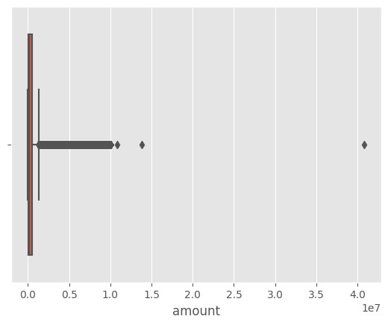
[27]:
sns
.
histplot(data
=
new_df, x
=
"
oldbalanceOrg
"
)
[27]: <Axes: xlabel='oldbalanceOrg', ylabel='Count'>
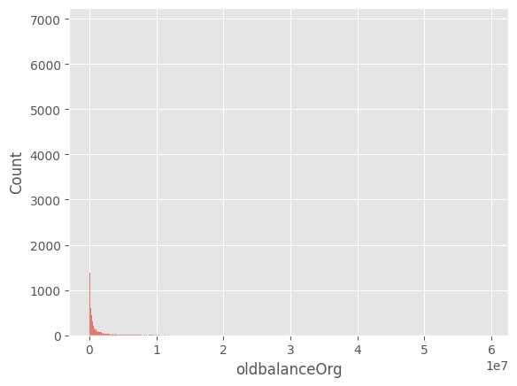
[28]:
df[
"
nameDest
"
]
.
value_counts()
[28]: nameDest
C1286084959 | 113
C985934102 | 109
C665576141 | 105
C2083562754 | 102
C248609774 | 101  …
M1470027725 | 1
M1330329251 | 1
M1784358659 | 1
M2081431099 | 1
C2080388513 | 1
Name: count, Length: 2722362, dtype: int64
[29]:
sns
.
boxplot(data
=
new_df, x
=
"
oldbalanceDest
"
)
[29]: <Axes: xlabel='oldbalanceDest'>
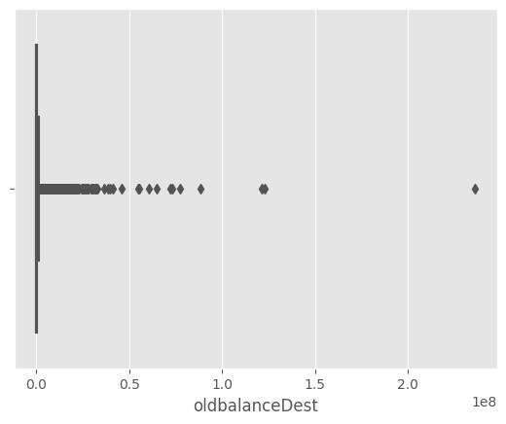
[30]:
sns
.
boxplot(data
=
new_df, x
=
"
newbalanceDest
"
)
[30]: <Axes: xlabel='newbalanceDest'>
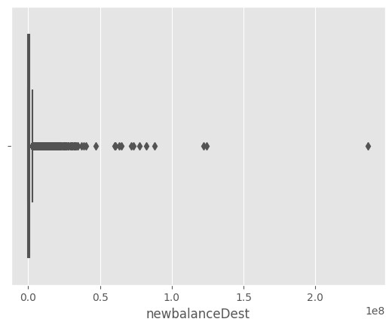
[31]:
sns
.
countplot(data
=
new_df, x
=
"
isFraud
"
)
[31]: <Axes: xlabel='isFraud', ylabel='count'>
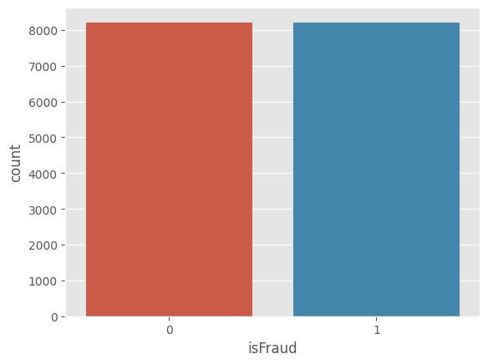

2.0.4 Bivariate analysis
The process of finding the relation between two features is called bivariate analysis
[32]: sns.jointplot(data=new_df, x="newbalanceDest", y="isFraud")
[32]: <seaborn.axisgrid.JointGrid at 0x2086ebe3c70>
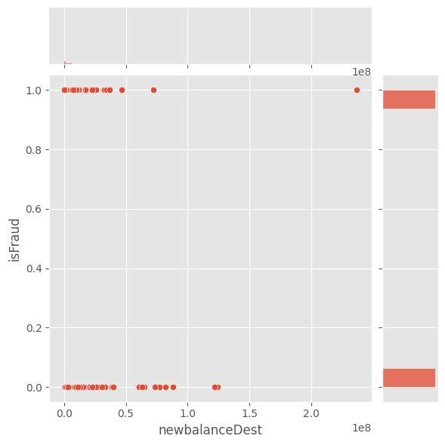
0 means legal transaction and 1 means fraudulent transaction
[33]: sns.countplot(data=new_df, x="type", hue="isFraud")
[33]: <Axes: xlabel='type', ylabel='count'>
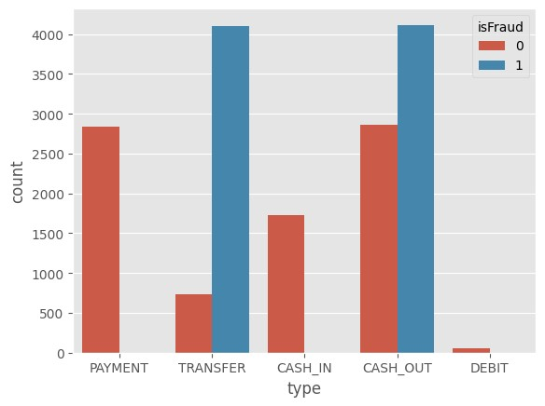
[34]: sns.boxplot(data=new_df, x="isFraud", y="step")
[34]: <Axes: xlabel='isFraud', ylabel='step'>
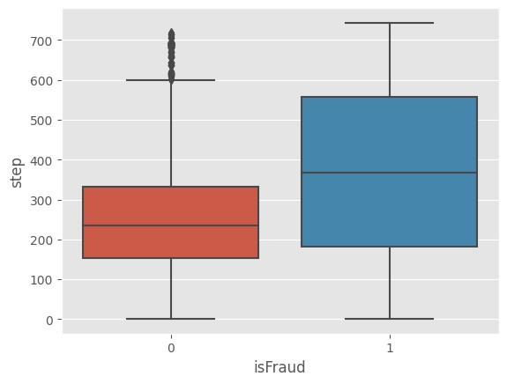
[35]: sns.boxplot(data=new_df, x="isFraud", y="amount")
[35]: <Axes: xlabel='isFraud', ylabel='amount'>
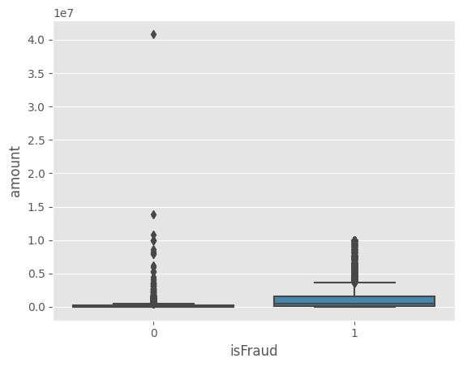
[36]: sns.boxplot(data=new_df, x="isFraud", y="oldbalanceOrg")
[36]: <Axes: xlabel='isFraud', ylabel='oldbalanceOrg'>
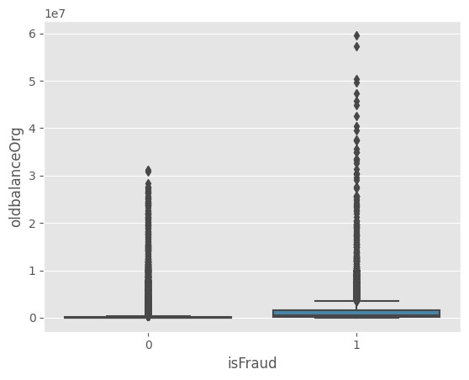
[37]: sns.boxplot(data=new_df, x="isFraud", y="newbalanceOrig")
[37]: <Axes: xlabel='isFraud', ylabel='newbalanceOrig'>
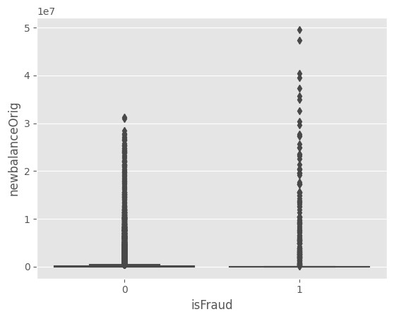
[38]: sns.violinplot(data=new_df, x="isFraud", y="oldbalanceDest")
[38]: <Axes: xlabel='isFraud', ylabel='oldbalanceDest'>
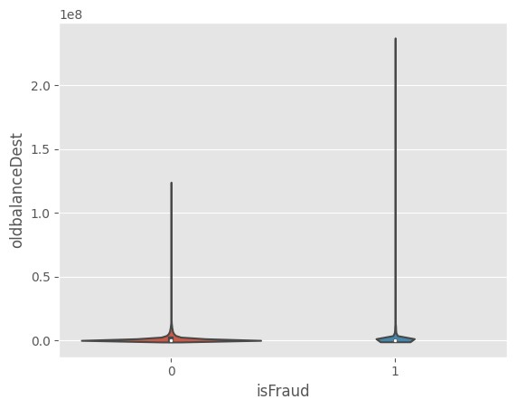
[39]: sns.violinplot(data=new_df, x="isFraud", y="newbalanceDest")
[39]: <Axes: xlabel='isFraud', ylabel='newbalanceDest'>
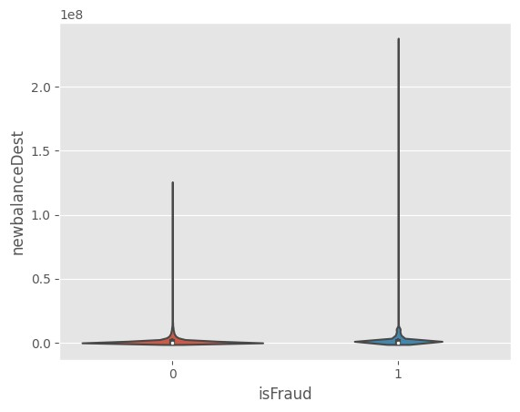

2.0.5 Descriptive analysis
The process of studying the basic features of data with the statistical process is called descriptive analysis
[40]:
new_df
.
describe(include
=
"
all
"
)
[40]: |  | step type amount nameOrig oldbalanceOrg \
count |  | 16426.000000 16426 1.642600e+04 16426 1.642600e+04
unique |  | NaN 5 NaN 16426 NaN
top |  | NaN CASH_OUT NaN C1894501645 NaN
freq |  | NaN 6977 NaN 1 NaN
mean |  | 303.528004 NaN 8.236633e+05 NaN 1.215890e+06
std |  | 194.265068 NaN 1.874245e+06 NaN 3.216881e+06
min |  | 1.000000 NaN 0.000000e+00 NaN 0.000000e+00
25% |  | 160.000000 NaN 3.600852e+04 NaN 1.037175e+04
50% |  | 282.000000 NaN 1.724345e+05 NaN 1.181601e+05
75% |  | 407.000000 NaN 5.425444e+05 NaN 7.800662e+05
max |  | 743.000000 NaN 4.083851e+07 NaN 5.958504e+07
 |  | newbalanceOrig nameDest oldbalanceDest newbalanceDest \
 | count | 1.642600e+04 16426 |  | 1.642600e+04 | 1.642600e+04
 | unique | NaN 16243 |  | NaN | NaN
 | top | NaN C2069255486 |  | NaN | NaN
 | freq | NaN | 3 | NaN | NaN
 | mean | 4.981792e+05 | NaN | 8.541002e+05 | 1.283866e+06
 | std | 2.449074e+06 | NaN | 3.585214e+06 | 3.963415e+06
 | min | 0.000000e+00 | NaN | 0.000000e+00 | 0.000000e+00
 | 25% | 0.000000e+00 | NaN | 0.000000e+00 | 0.000000e+00
 | 50% | 0.000000e+00 | NaN | 0.000000e+00 | 1.145759e+05
 | 75% | 0.000000e+00 | NaN | 5.062906e+05 | 1.086951e+06
 | max | 4.958504e+07 isFraud | NaN | 2.362305e+08 | 2.367265e+08
 | count | 16426.000000
 | unique | NaN
 | top | NaN
 | freq | NaN
 | mean | 0.500000
 | std | 0.500015
 | min | 0.000000
 | 25% | 0.000000
 | 50% | 0.500000
 | 75% | 1.000000
 | max | 1.000000

3 Data preprocessing
[41]:
new_df
.
shape
[41]: (16426, 10)
[42]:
new_df
.
drop([
"
nameOrig
"
,
"
nameDest
"
]
, axis
=
1
, inplace
=
True
)
df
.
columns
[42]: Index(['step', 'type', 'amount', 'nameOrig', 'oldbalanceOrg', 'newbalanceOrig',
'nameDest', 'oldbalanceDest', 'newbalanceDest', 'isFraud'], dtype='object')
[43]:
new_df
.
head()
[43]: | step type amount oldbalanceOrg newbalanceOrig \
2472014 | 204 PAYMENT 2711.51 155609.95 152898.44
1329496 | 137 PAYMENT 50062.45 0.00 0.00
3569677 | 260 TRANSFER 142407.65 0.00 0.00
1698217 | 159 PAYMENT 11379.43 25424.00 14044.57
5190368 369 CASH_IN 220293.91 293672.58 513966.49
oldbalanceDest newbalanceDest isFraud
2472014 0.00 0.00 0
1329496 0.00 0.00 0
3569677 830469.20 1181738.48 0
1698217 0.00 0.00 0
5190368 3017311.84 2797017.93 0
[44]:
new_df
.
tail()
[44]: step type amount oldbalanceOrg newbalanceOrig \
- 743 CASH_OUT 339682.13 339682.13 0.0
- 743 TRANSFER 6311409.28 6311409.28 0.0
- 743 CASH_OUT 6311409.28 6311409.28 0.0
- 743 TRANSFER 850002.52 850002.52 0.0
- 743 CASH_OUT 850002.52 850002.52 0.0
oldbalanceDest newbalanceDest isFraud
- 0.00 339682.13 1
- 0.00 0.00 1
- 68488.84 6379898.11 1
- 0.00 0.00 1
- 6510099.11 7360101.63 1

3.0.1 Checking null values
[45]:
new_df
.
isnull()
.
any()
[45]: step False
type False
amount False
oldbalanceOrg False
newbalanceOrig False
oldbalanceDest False
newbalanceDest False
isFraud False
dtype: bool
[46]:
new_df
.
isnull()
.
sum()
[46]: step 0
type 0
amount 0
oldbalanceOrg 0
newbalanceOrig 0
oldbalanceDest 0
newbalanceDest 0 isFraud 0
dtype: int64
Clearly there are no null values
[47]:
new_df
.
info()
<class 'pandas.core.frame.DataFrame'> Index: 16426 entries, 2472014 to 6362619 Data columns (total 8 columns):
# Column Non-Null Count Dtype
--- ------ -------------- -----
- step 16426 non-null int64
- type 16426 non-null object
- amount 16426 non-null float64
- oldbalanceOrg 16426 non-null float64
- newbalanceOrig 16426 non-null float64
- oldbalanceDest 16426 non-null float64
- newbalanceDest 16426 non-null float64
- isFraud 16426 non-null int64
dtypes: float64(5), int64(2), object(1) memory usage: 1.1+ MB

3.0.2 Handling outliers
[48]:
sns
.
boxplot(x
=
new_df[
"
amount
"
])
[48]: <Axes: xlabel='amount'>

There are outliers in the “amount” column which need to be removed
[49]:
q1
=
new_df[
'
amount
'
]
.
quantile(
0.25
)
q3
=
new_df[
'
amount
'
]
.
quantile(
0.75
)
iqr
=
q3
-
q1
upper_limit
=
q3
+
1.5
*
iqr
lower_limit
=
q1
-
1.5
*
iqr
mean
=
new_df[
'
amount
'
]
.
mean()
# Replace outliers with the mean value
new_df[
'
amount
'
]
=
np
.
where(new_df[
'
amount
'
]
>
upper_limit, mean,
␣
↪
new_df[
'
amount
'
])
new_df[
'
amount
'
]
=
np
.
where(new_df[
'
amount
'
]
<
lower_limit, mean,
␣
↪
new_df[
'
amount
'
])
[50]:
sns
.
boxplot(x
=
new_df[
"
amount
"
])
[50]: <Axes: xlabel='amount'>
Now outliers are removed in “amount” columns
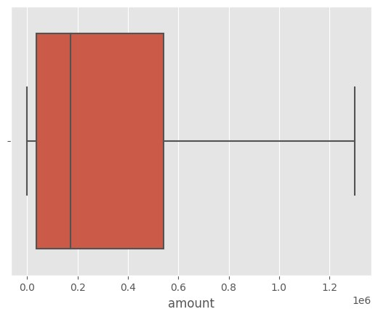
[51]: sns.boxplot(x=new_df["oldbalanceOrg"])
[51]: <Axes: xlabel='oldbalanceOrg'>
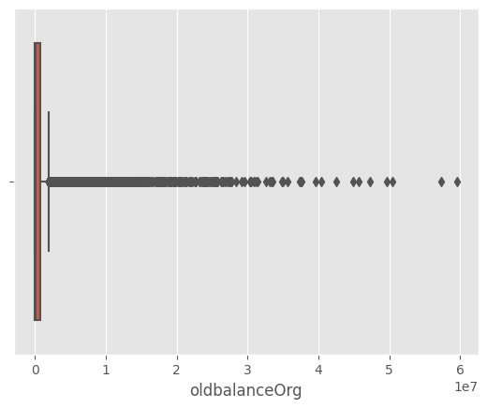
The column “oldbalanceOrg” has outliers which need to be treated
[52]:
q1
=
new_df[
'
oldbalanceOrg
'
]
.
quantile(
0.25
)
q3
=
new_df[
'
oldbalanceOrg
'
]
.
quantile(
0.75
)
iqr
=
q3
-
q1
upper_limit
=
q3
+
1.5
*
iqr
lower_limit
=
q1
-
1.5
*
iqr
mean
=
new_df[
'
oldbalanceOrg
'
]
.
mean()
# Replace outliers with the mean value
new_df[
'
oldbalanceOrg
'
]
=
np
.
where(new_df[
'
oldbalanceOrg
'
]
>
upper_limit, mean,
␣
↪
new_df[
'
oldbalanceOrg
'
])
new_df[
'
oldbalanceOrg
'
]
=
np
.
where(new_df[
'
oldbalanceOrg
'
]
<
lower_limit, mean,
␣
↪
new_df[
'
oldbalanceOrg
'
])
[53]: sns.boxplot(x=new_df["oldbalanceOrg"])
[53]: <Axes: xlabel='oldbalanceOrg'>
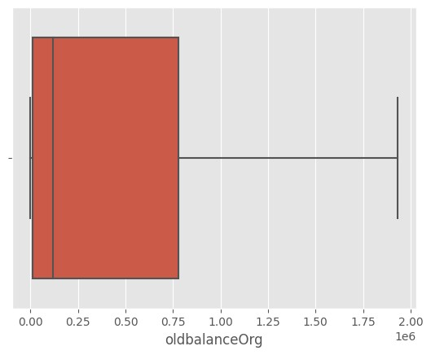
Now “oldbalanceOrg” is free of outliers
[54]:
sns
.
boxplot(x
=
new_df[
"
newbalanceOrig
"
])
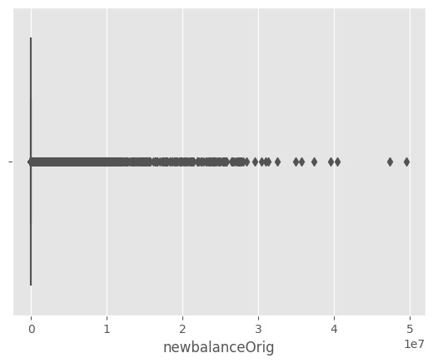
[54]: <Axes: xlabel='newbalanceOrig'> The column “newbalanceOrig” has outliers which need to be treated
[55]:
q1
=
new_df[
'
newbalanceOrig
'
]
.
quantile(
0.25
)
q3
=
new_df[
'
newbalanceOrig
'
]
.
quantile(
0.75
)
iqr
=
q3
-
q1
upper_limit
=
q3
+
1.5
*
iqr
lower_limit
=
q1
-
1.5
*
iqr
mean
=
new_df[
'
newbalanceOrig
'
]
.
mean()
# Replace outliers with the mean value
new_df[
'
newbalanceOrig
'
]
=
np
.
where(new_df[
'
newbalanceOrig
'
]
>
upper_limit,
␣
↪
mean, new_df[
'
newbalanceOrig
'
])
new_df[
'
newbalanceOrig
'
]
=
np
.
where(new_df[
'
newbalanceOrig
'
]
<
lower_limit,
␣
↪
mean, new_df[
'
newbalanceOrig
'
])
[56]: sns.boxplot(x=new_df["newbalanceOrig"])
[56]: <Axes: xlabel='newbalanceOrig'>
Now “newbalanceOrig” is free of outliers

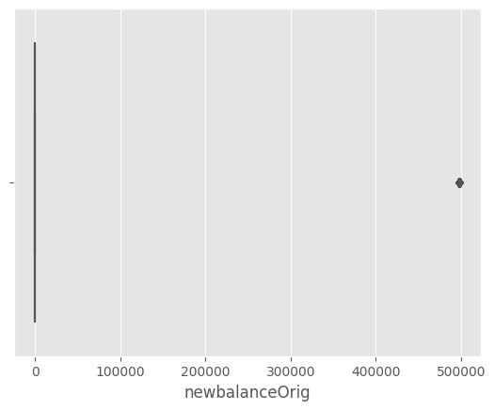
3.0.3 Handling categorial or object data using label encoding
[57]:
from
sklearn
.
preprocessing
import
LabelEncoder
[58]:
le
=
LabelEncoder()
new_df[
"
type
"
]
=
le
.
fit_transform(new_df[
"
type
"
])
[60]:
new_df[
"
type
"
]
.
value_counts()
[60]:
type
1 6977
4 4830
3 2834
0 1731
2 54
Name: count, dtype: int64
[63]:
le
.
classes_

[63]: array(['CASH_IN', 'CASH_OUT', 'DEBIT', 'PAYMENT', 'TRANSFER'], dtype=object)
[65]: map
[64]:
map
=
dict
(
zip
(
le
.
classes_,
range
(
len
(
le
.
classes_))))
[65]: {'CASH_IN': 0, 'CASH_OUT': 1, 'DEBIT': 2, 'PAYMENT': 3, 'TRANSFER': 4}

3.0.4 Dividing dataset into dependent and independent variable
[60]:
x
=
new_df
.
drop(
"
isFraud
"
, axis
=
1
)
y
=
new_df[
"
isFraud
"
]
[61]:
x
.
head()
[61]:
step type
amount oldbalanceOrg newbalanceOrig oldbalanceDest \
156272 12 0 193273.15 7.988900e+04 522204.069453 559880.30 6194917 573 0 139530.26 1.238643e+06 522204.069453 1028962.30 1199699 133 3 37315.10 1.139180e+05 522204.069453 0.00
186011 13 3 12722.06 4.601860e+03 0.000000 0.00
1157583 131 1 49391.70 0.000000e+00 0.000000 1872470.67
newbalanceDest
156272 366607.14
6194917 889432.04
1199699 0.00
186011 0.00
1157583 1921862.37
[62]:
y
.
head()
[62]: 156272 0
6194917 0
1199699 0
186011 0
1157583 0
Name: isFraud, dtype: int64
[63]:
type
(
x
)
[63]: pandas.core.frame.DataFrame
[64]:
type
(
y
)
[64]: pandas.core.series.Series

3.0.5 Splitting data into training and testing set
[65]:
from
sklearn
.
model_selection
import
train_test_split
[66]:
x_train, x_test, y_train, y_test
=
train_test_split(x, y, random_state
=
0
,
␣
↪
test_size
=
0.2
)
[67]:
print
(
x_train
.
shape)
print
(
x_test
.
shape)
print
(
y_test
.
shape)
print
(
y_train
.
shape)
(13140, 7)
(3286, 7)
(3286,)
(13140,)

4 Model building
Now that our data is clean, we can train it on different models and pick the best performing model

4.1 1. Random forest classifier
A Random Forest is an ensemble of decision trees. It builds multiple trees from random subsets of data and features, combines their predictions, and reduces overfitting to create a robust and accurate classification model.

4.1.1 Import model building libraries
[68]: from sklearn.ensemble import RandomForestClassifier from sklearn.metrics import accuracy_score

4.1.2 Initialising the model
[69]:
rfc
=
RandomForestClassifier()
rfc
[69]: RandomForestClassifier()

4.1.3 Training and testing the model
[70]:
rfc
.
fit(x_train, y_train)
[70]: RandomForestClassifier()
[71]:
# testing accuracy
y_test_predict1
=
rfc
.
predict(x_test)
test_accuracy
=
accuracy_score(y_test, y_test_predict1)
test_accuracy
[71]:
0.9914790018259282
[72]:
# training accuracy
y_train_predict1
=
rfc
.
predict(x_train)
train_accuracy
=
accuracy_score(y_train, y_train_predict1)
train_accuracy
[72]:
1.0

4.1.4 Evaluating performance of the model
[73]:
pd
.
crosstab(y_test, y_test_predict1)
[73]: col_0 0 1
isFraud
- 1609 21
- 7 1649
[ ]:
[74]:
print
(
classification_report(y_test, y_test_predict
1))
 | precision | recall f1-score | support
0 | 1.00 | 0.99 0.99 | 1630
1 | 0.99 | 1.00 0.99 | 1656
accuracy |  | 0.99 | 3286
macro avg | 0.99 | 0.99 0.99 | 3286
weighted avg | 0.99 | 0.99 0.99 | 3286
[ ]:
[ ]:

4.2 2. Decision trees
A Decision Tree is a tree-like model that makes decisions by recursively splitting the data based on features, aiming to create homogeneous groups. It’s a simple yet interpretable way to perform classification and regression tasks.

4.2.1 Import model building libraries
[75]:
from
sklearn
.
tree
import
DecisionTreeClassifier

4.2.2 Initialising the model
[76]:
dtc
=
DecisionTreeClassifier()
dtc
[76]: DecisionTreeClassifier()

4.2.3 Training and testing the model
[77]:
dtc
.
fit(x_train, y_train)
[77]:
DecisionTreeClassifier()
[78]:
# testing accuracy
y_test_predict2
=
dtc
.
predict(x_test)
test_accuracy
=
accuracy_score(y_test, y_test_predict2)
test_accuracy
[78]:
0.9902617163724894
[79]:
# training accuracy
y_train_predict2
=
dtc
.
predict(x_train)
train_accuracy
=
accuracy_score(y_train, y_train_predict2)
train_accuracy
[79]:
1.0
4.2.4 Evaluating the performance of the model
[80]:
pd
.
crosstab(y_test, y_test_predict2)
[80]: col_0 0 1 isFraud
- 1609 21
- 11 1645
[ ]:
[81]:
print
(
classification_report(y_test, y_test_predict
2))
 | precision | recall f1-score | support
0 | 0.99 | 0.99 0.99 | 1630
1 | 0.99 | 0.99 0.99 | 1656
accuracy |  | 0.99 | 3286
macro avg | 0.99 | 0.99 0.99 | 3286
weighted avg | 0.99 | 0.99 0.99 | 3286

4.3 3. ExtraTrees classifier
An ExtraTrees Classifier (Extremely Randomized Trees Classifier) is an ensemble machine learning model that builds multiple decision trees with a key difference from Random Forest. It adds randomness by selecting random subsets of features and choosing the best split points, which makes it computationally efficient. It combines the predictions from these trees to make accurate classifications and reduce overfitting.

4.3.1 Import model building libraries
[82]: from sklearn.ensemble import ExtraTreesClassifier

4.3.2 Initialising the model
[83]:
etc
=
ExtraTreesClassifier()
etc
[83]: ExtraTreesClassifier()

4.3.3 Training and testing the model
[84]:
etc
.
fit(x_train,y_train)
[84]:
ExtraTreesClassifier()
[85]:
# testing accuracy
y_test_predict3
=
etc
.
predict(x_test)
test_accuracy
=
accuracy_score(y_test, y_test_predict3)
test_accuracy
[85]:
0.9899573950091296
[86]:
# training accuracy
y_train_predict3
=
etc
.
predict(x_train)
train_accuracy
=
accuracy_score(y_train, y_train_predict3)
train_accuracy
[86]: 1.0

4.3.4 Evaluating the performance of the model
[87]:
pd
.
crosstab(y_test,y_test_predict3)
[87]: col_0 0 1
isFraud
- 1609 21
- 12 1644
[ ]:
[88]:
print
(
classification_report (y_test,y_test_predict
3))
 | precision | recall f1-score | support
0 | 0.99 | 0.99 0.99 | 1630
1 | 0.99 | 0.99 0.99 | 1656
accuracy |  | 0.99 | 3286
macro avg | 0.99 | 0.99 0.99 | 3286
weighted avg | 0.99 | 0.99 0.99 | 3286

4.4 4. Support vector machine classifier
A Support Vector Machine (SVM) Classifier is a powerful machine learning model used for both classification and regression tasks. It works by finding the best hyperplane that separates different classes in the data, aiming to maximize the margin between the classes. SVMs can handle linear and nonlinear data, making them effective for a wide range of applications, from image recognition to text classification.

4.4.1 Import model building libraries
[89]:
from
sklearn
.
svm
import
SVC
from
sklearn
.
metrics
import
accuracy_score

4.4.2 Initialising the model
[90]:
svc
=
SVC()
svc
[90]: SVC()

4.4.3 Training and testing the model
[91]:
svc
.
fit(x_train,y_train)
[91]:
SVC()
[92]:
# testing accuracy
y_test_predict4
=
svc
.
predict(x_test)
test_accuracy
=
accuracy_score(y_test, y_test_predict4)
test_accuracy
[92]:
0.8703590992087644
[93]:
# training accuracy
y_train_predict4
=
svc
.
predict(x_train)
train_accuracy
=
accuracy_score(y_train, y_train_predict4)
train_accuracy
[93]:
0.8622526636225266
4.4.4 Evaluating the performance of the model
[94]:
pd
.
crosstab(y_test,y_test_predict4)
[94]: col_0 0 1 isFraud
0 1621 9
1
417 1239
[ ]:
[95]:
from
sklearn
.
metrics
import
classification_report, confusion_matrix
print
(
classification_report(y_test, y_test_predict
4))
precision
recall f1-score
support
0 | 0.80 | 0.99 | 0.88 | 1630
1 | 0.99 | 0.75 | 0.85 | 1656
accuracy |  |  | 0.87 | 3286
macro avg | 0.89 | 0.87 | 0.87 | 3286
weighted avg | 0.89 | 0.87 | 0.87 | 3286

4.5 5. xgboost classifier
XGBoost (Extreme Gradient Boosting) Classifier is a popular and powerful machine learning algorithm known for its accuracy and speed. It belongs to the gradient boosting family and combines the predictions of multiple weak learners (typically decision trees) in an iterative manner. XGBoost is designed to minimize prediction errors and can handle complex datasets, making it a top choice for various classification tasks.

4.5.1 Import model building libraries
[96]:
import
xgboost
as
xgb
from
sklearn
.
metrics
import
accuracy_score

4.5.2 Initialising the model
[97]:
xgb1
=
xgb
.
XGBClassifier()
xgb1
[97]: XGBClassifier(base_score=None, booster=None, callbacks=None, colsample_bylevel=None, colsample_bynode=None, colsample_bytree=None, device=None, early_stopping_rounds=None, enable_categorical=False, eval_metric=None, feature_types=None, gamma=None, grow_policy=None, importance_type=None, interaction_constraints=None, learning_rate=None, max_bin=None, max_cat_threshold=None, max_cat_to_onehot=None, max_delta_step=None, max_depth=None, max_leaves=None, min_child_weight=None, missing=nan, monotone_constraints=None, multi_strategy=None, n_estimators=None, n_jobs=None, num_parallel_tree=None, random_state=None, …)

4.5.3 Training and testing the model
[98]:
xgb1
.
fit(x_train,y_train)
[98]: XGBClassifier(base_score=None, booster=None, callbacks=None, colsample_bylevel=None, colsample_bynode=None,
colsample_bytree=None, device=None, early_stopping_rounds=None, enable_categorical=False, eval_metric=None, feature_types=None, gamma=None, grow_policy=None, importance_type=None, interaction_constraints=None, learning_rate=None, max_bin=None, max_cat_threshold=None, max_cat_to_onehot=None, max_delta_step=None, max_depth=None, max_leaves=None, min_child_weight=None, missing=nan, monotone_constraints=None, multi_strategy=None, n_estimators=None, n_jobs=None, num_parallel_tree=None, random_state=None, …)
[99]:
# testing accuracy
y_test_predict5
=
xgb1
.
predict(x_test)
test_accuracy
=
accuracy_score(y_test, y_test_predict5)
test_accuracy
[99]:
0.9945222154595252
[100]:
# training accuracy
y_train_predict5
=
svc
.
predict(x_train)
train_accuracy
=
accuracy_score(y_train, y_train_predict5)
train_accuracy
[100]:
0.8622526636225266

4.5.4 Evaluating the performance of the model
[101]:
pd
.
crosstab(y_test, y_test_predict5)
[101]: col_0 0 1
isFraud
0 1617 13
1
5 1651
[ ]:
[102]:
from
sklearn
.
metrics
import
classification_report, confusion_matrix
print
(
classification_report (y_test, y_test_predict
5))
precision
recall f1-score
support
0 | 1.00 | 0.99 | 0.99 | 1630
1 | 0.99 | 1.00 | 0.99 | 1656
accuracy |  |  | 0.99 | 3286
macro avg | 0.99 | 0.99 | 0.99 | 3286
weighted avg | 0.99 | 0.99 | 0.99 | 3286

4.6 Comparing models
[103]: def compareModel(): print("Train accuracy for RFC: ",␣
↪accuracy_score(y_train_predict1,y_train)*100) print("Test accuracy for RFC: ", accuracy_score(y_test_predict1,y_test)*100) print("\n")
print("Train accuracy for DTC: ",␣
↪accuracy_score(y_train_predict2,y_train)*100) print("Test accuracy for DTC: ", accuracy_score(y_test_predict2,y_test)*100) print("\n")
print("Train accuracy for ETC: ",␣
↪accuracy_score(y_train_predict3,y_train)*100) print("Test accuracy for ETC: ", accuracy_score␣
↪(y_test_predict3,y_test)*100) print("\n")
print("Train accuracy for SVC: ",␣
↪accuracy_score(y_train_predict4,y_train)*100) print("Test accuracy for SVC: ", accuracy_score(y_test_predict4,y_test)*100) print("\n")
print("Train accuracy for XGB: ",␣
↪accuracy_score(y_train_predict5,y_train)*100) print("Test accuracy for XGB: ", accuracy_score(y_test_predict5,y_test)*100)
[104]: compareModel()
Train accuracy for RFC: 100.0
Test accuracy for RFC: 99.14790018259282
Train accuracy for DTC: 100.0
Test accuracy for DTC: 99.02617163724894
Train accuracy for ETC: 100.0
Test accuracy for ETC: 98.99573950091296
Train accuracy for SVC: 86.22526636225267 Test accuracy for SVC: 87.03590992087643
Train accuracy for XGB: 86.22526636225267
Test accuracy for XGB: 99.45222154595253
On comparing the training and testing of 5 different models trained by 5 different algorithms, we have found that XGBoost Classifier is the best model as it has the highest testing accuracy and is not overfitting.

4.7 Save the model
[105]:
import
pickle
pickle
.
dump(xgb1,
open
(
'
payments.pkl
'
,
'
wb
'
))
[66]:
new_df
[66]:
step type
amount oldbalanceOrg newbalanceOrig \
2472014 204 3 2711.510000 1.556100e+05 498179.214218
1329496 137 3 50062.450000 0.000000e+00 0.000000
3569677 260 4 142407.650000 0.000000e+00 0.000000 1698217 159 3 11379.430000 2.542400e+04 498179.214218
5190368 369 0 220293.910000 2.936726e+05 498179.214218
… … … … … …
- 743 1 339682.130000 3.396821e+05 0.000000
- 743 4 823663.257501 1.215890e+06 0.000000
- 743 1 823663.257501 1.215890e+06 0.000000
- 743 4 850002.520000 8.500025e+05 0.000000
- 743 1 850002.520000 8.500025e+05 0.000000
oldbalanceDest newbalanceDest isFraud
2472014 0.00 0.00 0
1329496 0.00 0.00 0
3569677 830469.20 1181738.48 0
1698217 0.00 0.00 0
5190368 3017311.84 2797017.93 0
… … … …
- 0.00 339682.13 1
- 0.00 0.00 1
- 68488.84 6379898.11 1
- 0.00 0.00 1
- 6510099.11 7360101.63 1
[16426 rows x 8 columns]
[ ]:

Flask Application Code:

Directory structure –
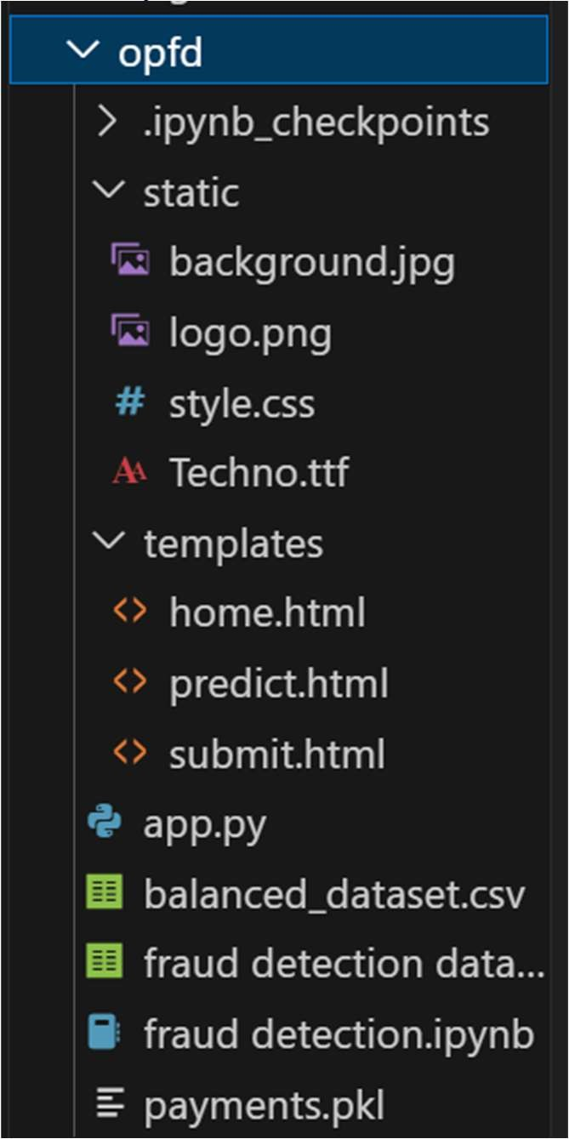

home.html
<!DOCTYPE html>
<html lang="en">
<head>
<meta charset="UTF-8">
<meta name="viewport" content="width=device-width, initial-scale=1.0">
<link rel="stylesheet" href="{{ url_for('static', filename='style.css') }}">

<link rel="stylesheet" href="https://fonts.googleapis.com/css2?family=Share+Tech+Mono&display=swap">
<link rel="stylesheet" href="https://www.dafont.com/techno-2.font">
<link rel="icon" href="static/logo.png" type="image/png">
<title>Online Payments Fraud Detection</title>
</head>
<body style="background-image: url('/static/background.jpg');">
<h1 class="google-font">Online Payments Fraud Detection</h1>
<div class="content google-font">
The Online Payments Fraud Detection project addresses the growing concerns
related to the surge in online credit/debit card transactions, which has concurrently led to an increase in fraudulent activities.

Recognizing the need for effective fraud detection, our solution employs machine learning
classification algorithms, including Decision Tree, Random Forest, SVM,
Extra Tree Classifier, and XGBoost Classifier. This diverse set of algorithms aims to enhance accuracy and overcome specific drawbacks associated with traditional approaches. By leveraging these algorithms, we predict and further process potential frauds, particularly focusing on detecting changes in transaction behavior.

The proposed method becomes crucial in handling the substantial volume of data inherent in credit/debit card transactions. After
training and testing the data with various algorithms, the model exhibiting the highest performance is selected and saved in a pkl format. To ensure practical usability, we integrate this predictive model with a Flask web application, providing users with a seamless and intuitive interface for real-time fraud detection, thereby fortifying the security of online payment systems.
</div>
<div class="buttons google-font">
<a href="{{ url_for('home') }}">Home</a>
<a href="{{ url_for('predict') }}">Predict</a>
</div>
</body>
</html>

predict.html

<!DOCTYPE html>
<html lang="en">
<head>
<meta charset="UTF-8">
<meta name="viewport" content="width=device-width, initial-scale=1.0">
<link rel="stylesheet" href="{{ url_for('static', filename='style.css') }}">

<link rel="stylesheet" href="https://fonts.googleapis.com/css2?family=Share+Tech+Mono&display=swap">
<link rel="stylesheet" href="https://www.dafont.com/techno-2.font">
<link rel="icon" href="static/logo.png" type="image/png">
<title>Predict</title>
</head>
<body style="background-image: url('/static/background.jpg');">
<h1 class="google-font">Online Payments Fraud Detection</h1>
<div class="content google-font">
<form action="{{ url_for('predict') }}" method="post">
<label for="step">Step:</label><br>
<input type="text" name="step" required><br><br>
<label for="type">Type:</label><br>
<input type="text" name="type" required><br><br>
<label for="amount">Amount:</label><br>
<input type="text" name="amount" required><br><br>
<label for="oldbalanceOrg">Old Balance Org:</label><br>
<input type="text" name="oldbalanceOrg" required><br><br>
<label for="newbalanceOrig">New Balance Orig:</label><br>
<input type="text" name="newbalanceOrig" required><br><br>
<label for="oldbalanceDest">Old Balance Dest:</label><br>
<input type="text" name="oldbalanceDest" required><br><br>
<label for="newbalanceDest">New Balance Dest:</label><br>
<input type="text" name="newbalanceDest" required><br><br>
<button class="google-font" type="submit">Submit</button>
</form>
</div>
<div class="buttons google-font">
<a href="{{ url_for('home') }}">Home</a>
<a href="{{ url_for('predict') }}">Predict</a>
</div>
</body>
</html>

submit.html

<!DOCTYPE html>
<html lang="en">
<head>
<meta charset="UTF-8">
<meta name="viewport" content="width=device-width, initial-scale=1.0">
<link rel="stylesheet" href="{{ url_for('static', filename='style.css') }}">

<link rel="stylesheet" href="https://fonts.googleapis.com/css2?family=Share+Tech+Mono&display=swap">
<link rel="stylesheet" href="https://www.dafont.com/techno-2.font">
<link rel="icon" href="static/logo.png" type="image/png">
<title>Result</title>

</head>
<body style="background-image: url('/static/background.jpg');">
<h1 class="google-font">Online Payments Fraud Detection</h1>
<div class="buttons google-font">
<a href="{{ url_for('home') }}">Home</a>
<a href="{{ url_for('predict') }}">Predict</a> </div>
<div class="content google-font">
<h2>Result:</h2>
<p>This trasaction is {{ result }}</p>
</div>
</body>
</html>

style.css

h1{ color: white; font-size: 50px; font-family: 'Times New Roman', Times, serif;
} body { font-family: Arial, sans-serif; margin: 0; padding: 0; background-size: cover; background-repeat: no-repeat;
}

.google-font {
font-family: 'Share Tech Mono', sans-serif; color: white; padding: 20px;
}

.buttons { position: absolute; top: 20px; right: 20px;
}

.buttons a { color: white; text-decoration: none; padding: 10px; margin: 0 10px; border: 1px solid white; border-radius: 5px;
}

.content { padding: 20px;
color: white;
max-width: 600px;
} button { color: white; background: none; text-decoration: none; border: 1px solid white; border-radius: 5px;
}

app.py

from flask import Flask, render_template, request import pandas as pd import joblib import os
app = Flask(__name__)
current_dir = os.getcwd()
model_path = os.path.join(current_dir, 'payments.pkl')
if os.path.exists(model_path):
model = joblib.load(model_path) else:
print(f"Model file '{model_path}' not found.")

@app.route('/') def home():
return render_template('home.html')

@app.route('/predict', methods=['GET', 'POST']) def predict(): if request.method == 'POST':
features = [ float(request.form['step']), float(request.form['type']), float(request.form['amount']), float(request.form['oldbalanceOrg']), float(request.form['newbalanceOrig']), float(request.form['oldbalanceDest']), float(request.form['newbalanceDest'])
]
df = pd.DataFrame([features], columns=['step', 'type', 'amount',
'oldbalanceOrg', 'newbalanceOrig', 'oldbalanceDest', 'newbalanceDest'])
prediction = model.predict(df)[0]

result = "Fraud" if prediction == 1 else "Not Fraud"

return render_template('submit.html', result=result)
return render_template('predict.html')
if __name__ == '__main__': app.run(debug=True)

Output pages:

home.html



predict.html



submit.html

For input A,





For input B,





